**Static and Dynamic Languages.**

**Static:** -

* Perform type checking at compile time.

* Errors will show in compile time.

* Declare datatype before you use it.

* More control.

Ex: int a = 10;

* In above given example, the compiler checks the given variable data type in static language.

**Dynamic:** -

* Perform type checking at runtime.

* Error might not show till program runs.

* No need to declare datatype of variables.

* Saves time in writing but might give error at runtime.

Ex: a = 10

* In above given example, the dynamic language checks the datatype is runtime.

**Stack and Heap Memory: -**

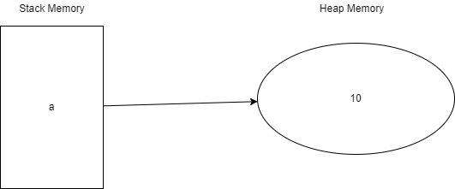

a = 10 Object

Reference Variable

**Garbage Collection:** - Object that do not have reference variable, the object will be removed by the memory by garbage collection.